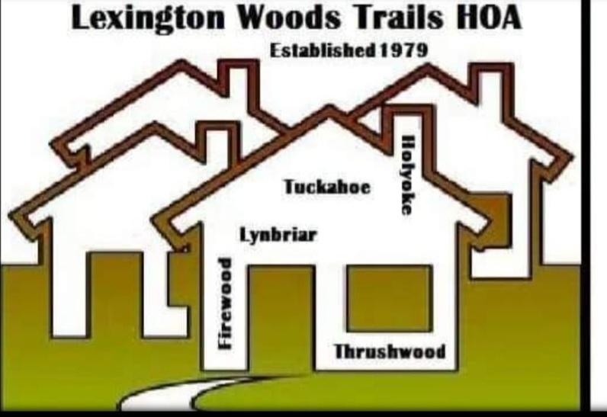

**Lexington Woods Trails HOA**

**P.O.Box 1959**

**Spring, Texas 77383**

**832-447-3146**

[**lexingtonwoodstrailshoa@hotmail.com**](mailto:lexingtonwoodstrailshos@hotmail.com)

**Violation Enforcement Guidelines and Fine Policy for**

**Lexington Woods Trails Community Association, Inc.**

In accordance with the Declaration and Covenants, Conditions and Restrictions (“Restrictions”) for Lexington WoodsTrails Community Association, Inc, filed and recorded on the Harris County Real Property Records on this day January 30, 2024, File No._________, the Board of Directors of Lexington Woods Trails Community Association, Inc (“Association”) has the authority to enforce restrictions, rules and regulations set out in the DCCR and any amendments thereafter.

In accordance with the Texas Property Code 209.0061, the following guidelines and policies adopted by the Board of Directors applied to the fining to enforce the restrictions. The rules and regulations do not replace the Restrictions filed in the real property records, and the procedures and fines set forth in this policy are in addition to any remedy allowed by the Restrictions, at Law, or in equity.

**ENFORCEMENT ACTION BY THE ASSOCIATION**

The Association has been empowered to fine violators in accordance with the Restrictions in Articles II, Use Restrictions.

Specifically, Sections 1 through 20, Rules and Regulations regarding Lot Maintenance numbers 1-7.

Accordingly, the following procedure and fine schedule will apply to Owners and/or Tenants found violating the Restrictions or any applicable Rules and Regulations.

**The Association can add categories which can include generally “ maintenance” or “ upkeep” of a lot. It would depend on what specific use restrictions are added to the restrictions.**

**In accordance with the rules, the fines policy MUST include categories. Though, the fine for each category can be the same if the board sees fit.**

**Sec. 209.0061. ASSOCIATION POLICIES; FINES. This section does not apply to a property owners’ association that is not authorized by the association's dedicatory instrument to levy a fine.**

**(b) A property owners’ association board shall adopt and enforcement policy regarding the levy of fines by he property owners’ association THe policy must include:**

1. **General categories of restrictive covenants for which the association may assess fines;**
2. **A schedule of fines for each category of violation; and**
3. **Information regarding hearings described by Section 209.007,**

**( c) The enforcement policy adopted pursuant to Subsect ( b) may reserve the board's authority to levy a fine from the schedules of fines that varies on a case -by-case basis.**

**( d) Each property owners’ association shall:**

1. **Provide a copy of the policy to an owner of each property in the subdivision by;**
2. **Posting the policy on the internet website maintained by the property owners’ association or an agent acting on behalf of the association and accessible to members of the association;**
3. **Annually sending a copy of the policy, separately or included in routine communication from the property owners’ association to property owners, by;**

**(i) hand delivery to the owner**

**(ii) first class mail to the owner’s last known mailing address; or**

**(iii) email to an email address provided to the property owners’ association by the owner; and**

**( 2) make the policy available on any public accessible Internet website maintained by the property owners association or an agent on behalf of the association.**

**_____________________________________________________________________**

**_NOTICE_________VIOLATION NOTICE _________FINE or ACTION__________**

**_1ST____________Courtesy Letter__________No Fine, Sent via regular mail____**

***_2nd*____________ Warning Letter__________ Sent Via CErtified Mail__________**

**_3rd_____________Fee Letter with Charge____Fine $100, sen t via Certified Mail_**

**_4th_____________Fee Letter with Charge____Fine $200, sent via Certified Mail_**

* **If the violation is a curable violation , the letter will provide a (30) days to correct the violation, and if not corrected the Association will have the authority to enter, or direct a contractor to enter the property a d perform the maintenance or repair at the Owner's expense, which will be applied to the Owners’s account. The Association is not liable for the trespass if the violation is present at the time the Association or it’s agents enter the property to perform maintenance or repair any part of the property due to the violation.**
* **If the Board determines a violation is non-curable ( hazardous to the health and safety of the neighborhood residents) legal action may be initiated without prior notice, and an immediate fine up to $1000 may be imposed without notice.**

Each violation will be considered a separate violation. Owner will be sent notice with each separate violation pursuant to the fining schedule referenced above.

All charges are secured by a continuing lienas set forth in the Article II Use Restrictions for Lexington Woods Trails Community Association, Inc filed in the real property record record of Harris County, file number________. Failure to pay any charges may result in Judicial or nonjudicial proceedings by the association pursuant to the Restrictions.

**The First Letter** is a courtesy letter sent via regular mail or by electronic mail

**The Second letter** will be sent via certified mail and will warn of a fine if the violation is not cured within thirty (30) days of the date of the letter.

**The third letter** with fine assessed will be sent via certified mail and will warn of another fine of violation is not cured within thirty(30) days of the date of the letter. Owners, their agents, dependents or guests, accused of any violation may refute the fines through a hearing with the Association Board, the Board’s appointed representative, or the Association Attorney.

**The fourth letter** with fine assessed will be sent via certified mail and warn of another fine if the violation is not cured within thirty(30) days of the date of the letter. Owners, or their agents, dependents or guests, accused of any violation may refute the fines through a hearing with the Association Board, the Board’s representative, or the Association Attorney.

Owners unable to correct the violation within the prescribed thirty (30) days may submit a plan for correction for the Boards consideration. All such submission or responses . including updates on what is being done to correct the problem or any appeals to the violation, must be submitted in writing ( letter, facsimile or by email).

The procedures set forth above shall in no way prelude the Board from pursuing aby remedies available under the Association governing documents, or under applicable law or in equity with regard to enforcement of the Restrictions, Rules and Regulations, or other governing documents, such as maintaining a lawsuit to restrain or enjoin any breach of the provisions if the Restrictions or any other applicable rules.

**APPEAL/HEARINGS**

If an Owner receives a letter from the Association and disagrees with the violation notices or otherwise wishes to discuss the matter, the Owner may send a written request for a hearing directly to the Secretary of the Association via regular mail or via electronic mail at [lexingtonwoodsrailshoa@hotmail.com](mailto:lexingtonwoodsrailshoa@hotmail.com). The Owner must send a written request for hearing , either by email, written correspondence, or fax, within 30 days of receiving a violation letter from the Association.

Failure to retrieve or sign for certified mailings from the Association, either in person or at the UNited States Postal Office, is not grounds for an appeal and will not extend the number of days when an appeal can be submitted to the Association.

A hearing will be held within 30 days of the date the Association or its agents receive a written request for a hearing from the Owner. The Association or its agent will provide the Owner with a date, time and place for the hearing at least ten(10) days before the date the hearing is scheduled. THe Association shall provide the Owner with a Board packet ten (10) days before the hearing that details the reasons for issuing the violation and includes any pictures that the Association reviewed as evidence to issue the violation notice. Attorney fees shall not be attached to the owner's account before the hearing requested by the Owner.

IN WITNESS THEREOF , this Policy is execute on the 2nd day of February, 2024

_________________________________

_________________________________

_________________________, President

STATE OF TEXAS §

§

COUNTY OF HARRIS §

BEFORE ME, on this day personally appeared Wanda Wilcox, the President of Lexington Woods Trails Community Association, Inc., known by me the person whose name is subscribed to the foregoing instrument, and acknowledged to me and she executed the same for the purposes and consideration therein expressed and in the capacity therein and herein stated and is the act and deed of said corporation.

Given under my hand and seal od office, this 2nd day of February, 2024

__________________________________________________

**Notary**